  **School Of Computer Science Issue Date:** January 13, 22

**University Of Petroleum and Energy Studies**

 **P.O. Bidholi, Via-Prem Nagar DEHRADUN-248007**

**Major**

**Bachelors of Technology in Computer Science &**

**Engineering Minor**

|  |  |  |  |  |  |  |  |  |  |
| --- | --- | --- | --- | --- | --- | --- | --- | --- | --- |
| **Project Title** | | Saksham – AI Powered Communication Solution for Disabled | | | | | **Mentor Name** | **Project Number** | |
| Bikram Pratim Bhuyan | |
| **S. No.** | | **Roll Number** | **Branch** | **Name** | **Role** | | | **Signature** |
| 1 | | R177219194 | B. Tech. CSE AI & ML B-3 Sem-VI | Utkarsh Gupta | Developer & Team Leader | | |  |
| 2 | | R177219206 | B. Tech. CSE AI & ML B-6 Sem-VI | Aradhya Singh | Developer & Version Control | | |  |
| 3 | | R177219136 | B. Tech. CSE AI & ML B-6 Sem-VI | Priyal Gupta | Developer & Documentation | | |  |
|  | |  |  |  |  | | |  |

_____________________________________________________ __________________________________________________

|  |  |  |
| --- | --- | --- |
| **Project Mentor** |  | **Head Of Department** |

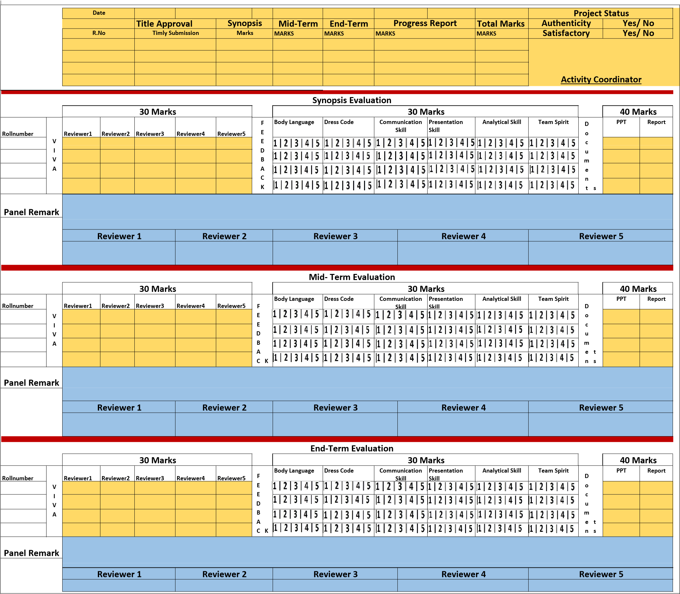

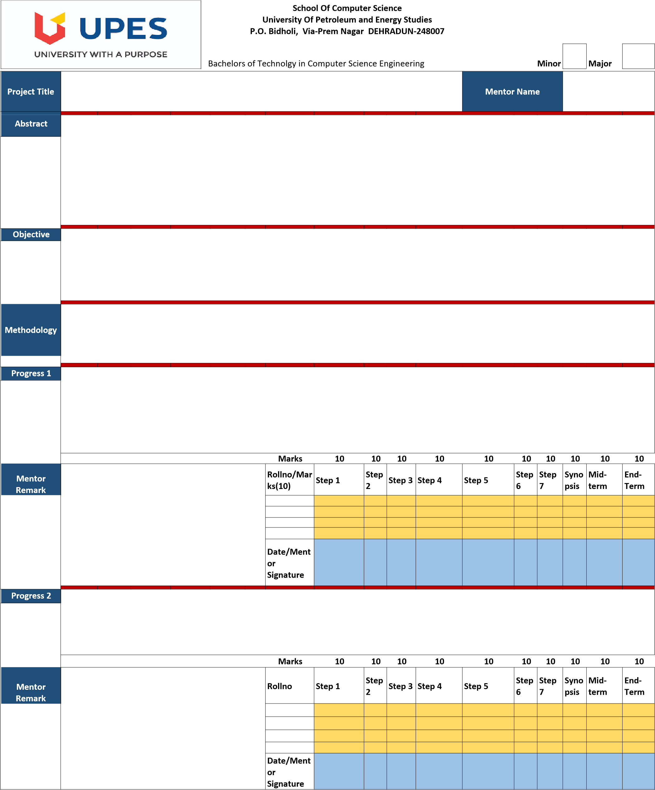

1. Developed Sign language recognition system.
2. Constructed the hardware.
3. Combined all the modules.
4. Developed GUI
5. Voice to text Model
6. Text to voice Model

First we will be developing all the AI models, Speech recognition and Sign Language recognition. Further the hardware for braille will be developed and at last the User interface will be developed.

The objective is to develop remote communication software accessible to normal, blind, dumb and deaf people for interaction. Thereafter, construct hardware i.e., an interactive, wireless refreshable "Braille" device that would be connected to the software to facilitate communication for blind people.

Single point solution for communication gap between blind, deaf, mute and normal population. Application is able to convert sign language, voice, braille & text to each other which enables almost everyone to be able to communicate with anyone. The sign language recognition will be achieved through computer vision, voice recognition will be achieved by DNN, braille will be achieved by a sophisticated wireless hardware.

Saksham – AI Powered Communication Solution for Disabled

Bikram Pratim Bhuyan

**Guideline: 1)** A project group can be of maximum 4 members and no alteration in the group member will be entertained later.

**Guideline: 2)** Methodology should have following steps Step1: Literature Review; Step2: Identification of Requirement (Type of Data source, Amount of Data, & Format of Data); Step3: Identification of Algorithm; Step 4: Comparative study; Step5: Design and Development of System/Architecture; Step 6: Implementation; Step7: Results **Guideline:3)** Student should upload softcopies of all the documents (reports and power point presentations) in “Project Directory”, 24 hrs prior to evaluation. **Guideline:4)** Panel member will give feedback to individual on the scale of 1 to 5 and this scale will change for defaulter i.e., 1 to 3 scale.

1: Poor 2: Average 3: Good 4: Excellent 5: Outstanding